Abstract

The railway reservation system facilitates the passengers to enquiry about the trains available on the basis of source and destination, booking and cancellation of tickets, enquiry about the status of the booked ticket, etc.

ONLINE RAILWAY RESERVATION SYSTEM

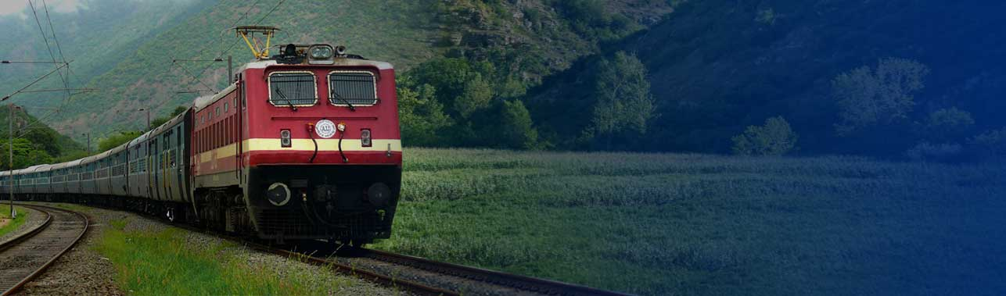

# Introduction

This system is designed for the online reservation of railway tickets for travel between any destinations which is a part of Indian Railway network. This system enables the Advance booking in any class, against general and ladies quota, on payment of fare in full for adults and children, a maximum of six berths/seats at a time, for journey between any two stations served by a train.

It also provides details about

1. Time table

2. Train fares

3. Current status of reservation position

4.Train available between a pair of stations

5.Accommodation available for a train/date combination

The user of this system should first register for any interaction with the system. Once registered, he/she will be provided with a username and password for the user to log in. After logging in the user should select the kind of activity he would like to perform like booking a ticket, canceling a ticket, look out for help and so on. A person can check the train timings, train fares and other trains information without login.

# List of Stack Holders

|  |  |  |  |  |
| --- | --- | --- | --- | --- |
| **S No.** | **Name** | **Email Id** | **Role** | **Racl** |
| 1 | Shammi kapoor | [Shammi.kapoor@capgemini.com](mailto:Shammi.kapoor@capgemini.com) | CG Mentor | I,C |
| 2 | Hariom Dubey | [hariom.dubey@technocratsgroup.edu.in](mailto:hariom.dubey@technocratsgroup.edu.in) | TIT Mentor | A |
| 3 | Dr. Manoj Tyagi | [hodtitcse@technocratsgroup.edu.in](mailto:hodtitcse@technocratsgroup.edu.in) | TIT Mentor | A,I |
| 4 | Vaibhav Gupta | vaibhavgupta812246@gmail.com | TIT Student | R |
| 5 | Ritesh Kumar | riteshckumar48@gmail.com | TIT Student | R |
| 6 | Ashmit Khare | [asmitkhare100@gmail.com](mailto:asmitkhare100@gmail.com) | TIT Student | R |
| 7 | Novin Kale | novinkale20@gmail.com | TIT Student | R |

# \*\*R=Responsible; A=Accountable; C=Consulted; I=Informed

# Functional Overview



**Administrator**



**Passenger**



# Functional Requirements

USER-

* User can signUp for Create account
* User can signIn for Reservation
* User and Admin can see the seat Avaliability
* User can apply for Book Ticket
* User can apply for cancel ticket

ADMIN-

* Admin can see and Update the Train Status

# Scope & Purpose

Purpose

The purpose of the source is to describe the railway reservation system which provides the train timing details, reservation, billing and cancellation on various types of reservation mainly,

* + - Conform reservation for conform seat.
    - Reservation against cancellation.
    - Waiting list reservation.
    - Online reservation.
    - Tatkal reservation.

Scope

It may help collecting perfect management in details. In a very short time, the collection will be obvious, simple and sensible. It will help a person to know the management of the past year perfectly and vividly. It also helps in current all works related to railway reservation system. It will be also reduced the cost of collecting the management and collection procedure will go on smoothly.

# Functional Flow Diagram

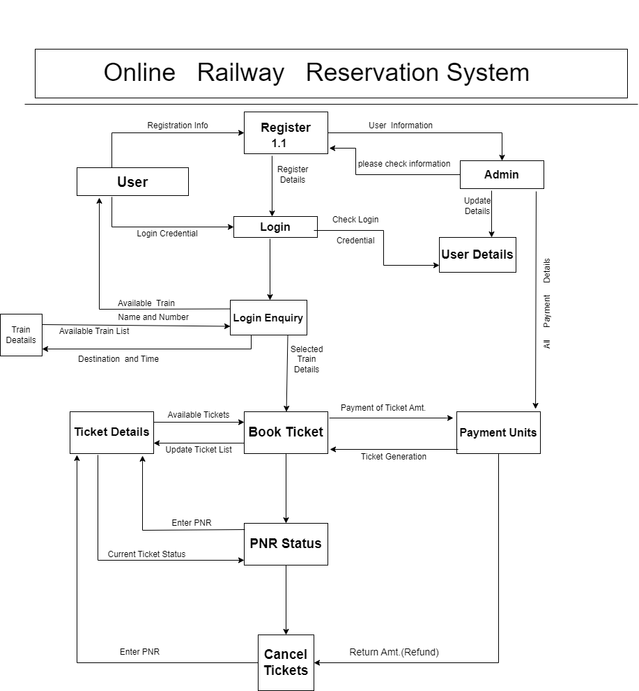

## UI Mockup

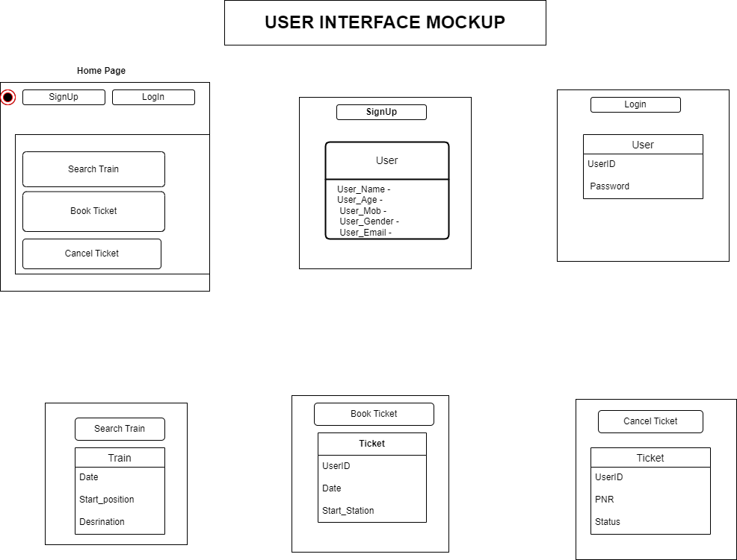

# Technical Architecture

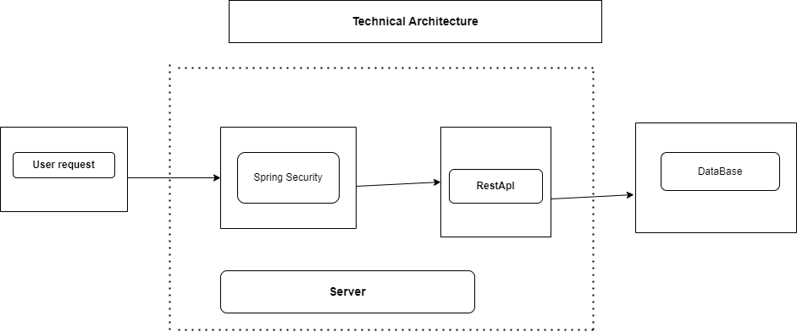

# Sequence Diagram



# Class Diagram

# functional_diagram.drawio.png

# ER Diagram

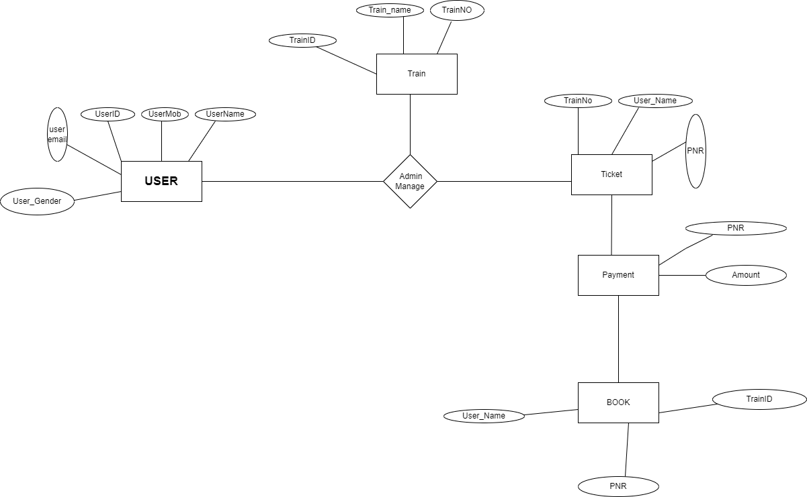

# Test Scenario

1. User able to sign-up with valid email-id and password
2. User is able to login with valid credentials
3. Check correct train details
4. Check correct user-id for payment
5. Check updates train list
6. Book ticket in correct train

# Tools & Technologies Used

# FRONT-END

# HTML

# CSS

# JAVA SCRIPT

# BACK-END

# SPRING CORE

# SPRING BOOT

# SPRING MVC

# SPRING REST

# DATABASE

# POSTGRES SQL

# IDE

# ECLIPSE

# SOFTWARE REQUIRED

# O/S -WINDOWS/LINUX/MAC

# WEB SERVER

# Apache Tomcat v-9.0

# SECURITY

# Spring Security

# PROGRAMMING LANGUAGE

# JAVA

# TESTING TOOLS

# Junit & Mockito

# UI/Web Development Framework

# React

# Versioning Section

|  |  |  |  |  |  |  |
| --- | --- | --- | --- | --- | --- | --- |
| Date | Version | Author | Reviewer | Approved date | Approve | Remarks |
| 28/03/23 | 01 | Vaibhav  Ritesh  Novin  Asmit | Shammi Kapoor | 28/03/23 |  |  |
|  |  |  |  |  |  |  |